CS372 – Lab 2

Craig Ricker

April 28, 2019

Table of Contents

The Basic HTTP GET/response interaction 1

The HTTP CONDITIONAL GET/response interaction 7

Retrieving Long Documents 9

HTML Documents with Embedded Objects 13

Section 5 HTTP Authentication 15

# The Basic HTTP GET/response interaction

1. Is your browser running HTTP version 1.0 or 1.1? What version of HTTP is the server running?  
   Both my browser and server are running HTTP 1.1  
   This is visible in the first line of both HTTP messages (the GET and the response). Outlined in orange in the below screen shot  
   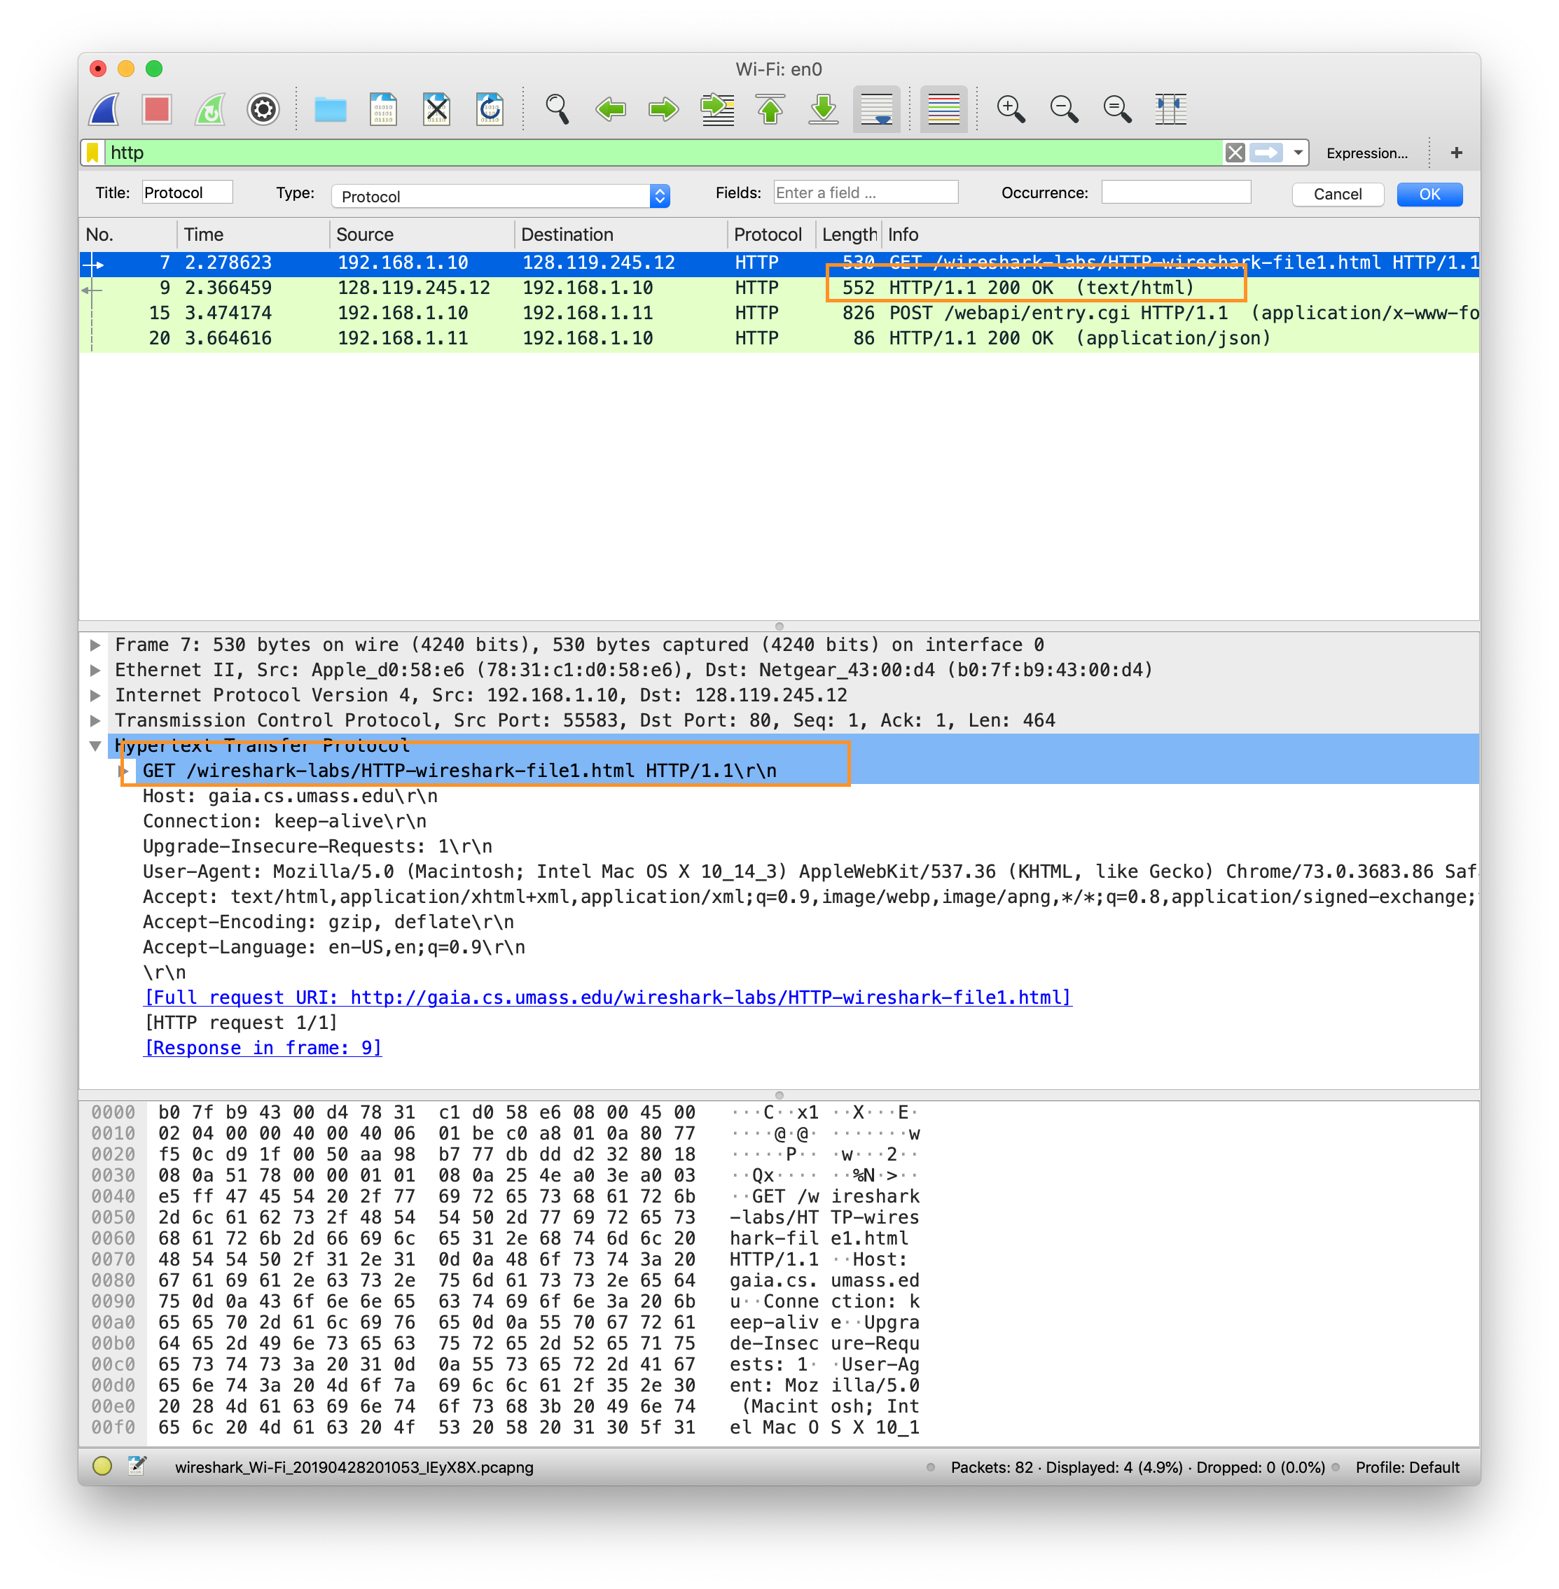
2. What languages (if any) does your browser indicate that it can accept to the server?  
   It can accept English, this is visible in the initial GET request’s hearder, under the “Accept-Language” field. Highlighted in orange in the below screen shot  
   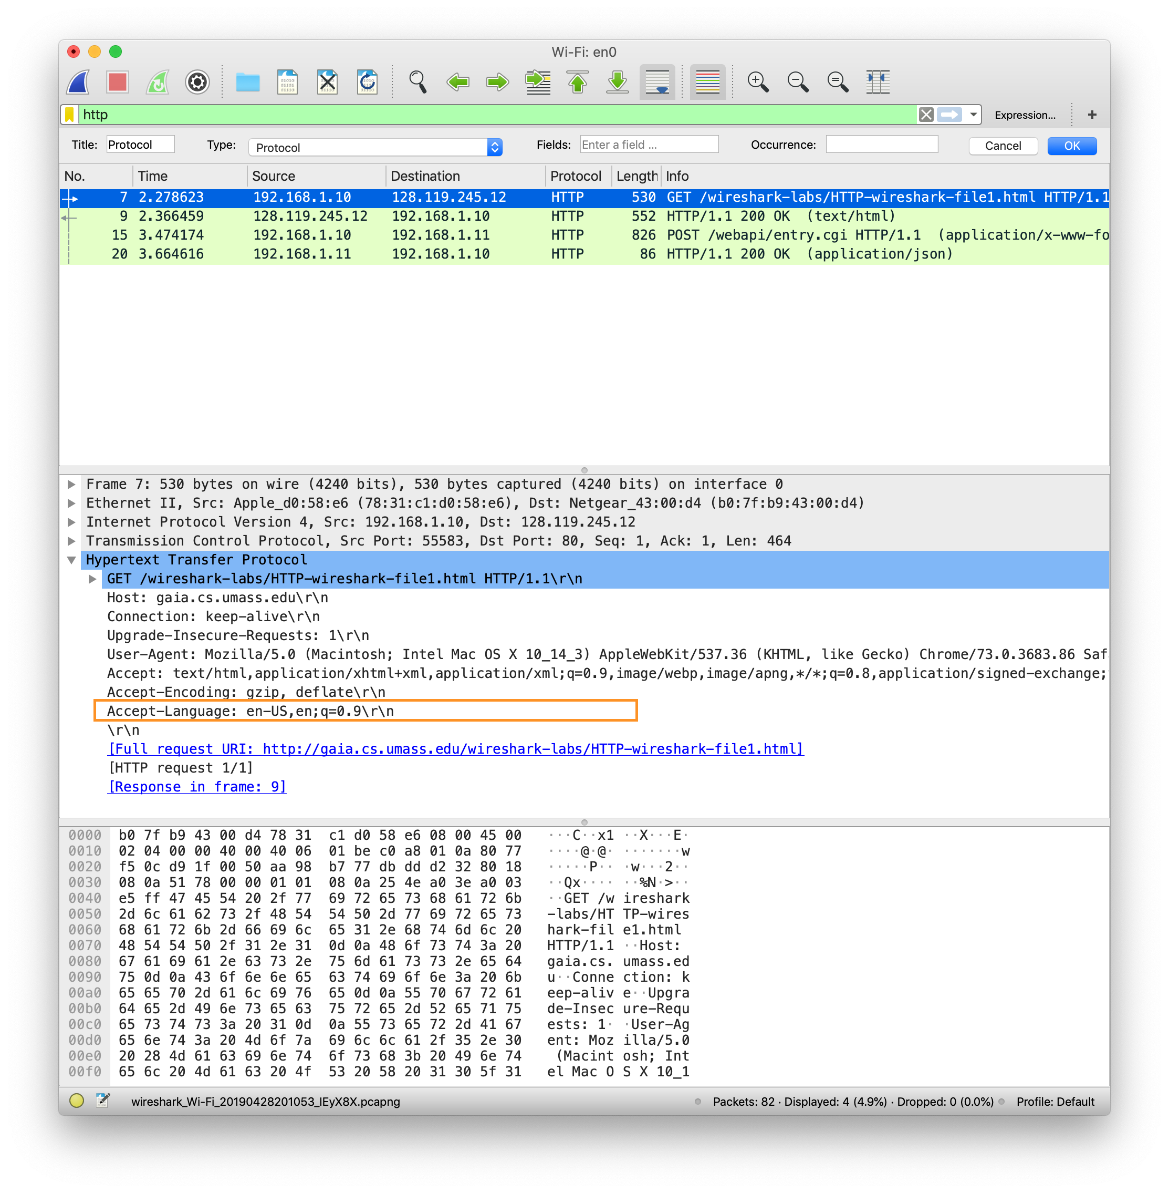
3. What is the IP address of your computer? Of the gaia.cs.umass.edu server?  
   My IP: 192.168.1.10 visible under the source of GET request – highlighted in orange  
   Server IP: 128.119.245.12 visible under the GET destination – highlighted in green  
   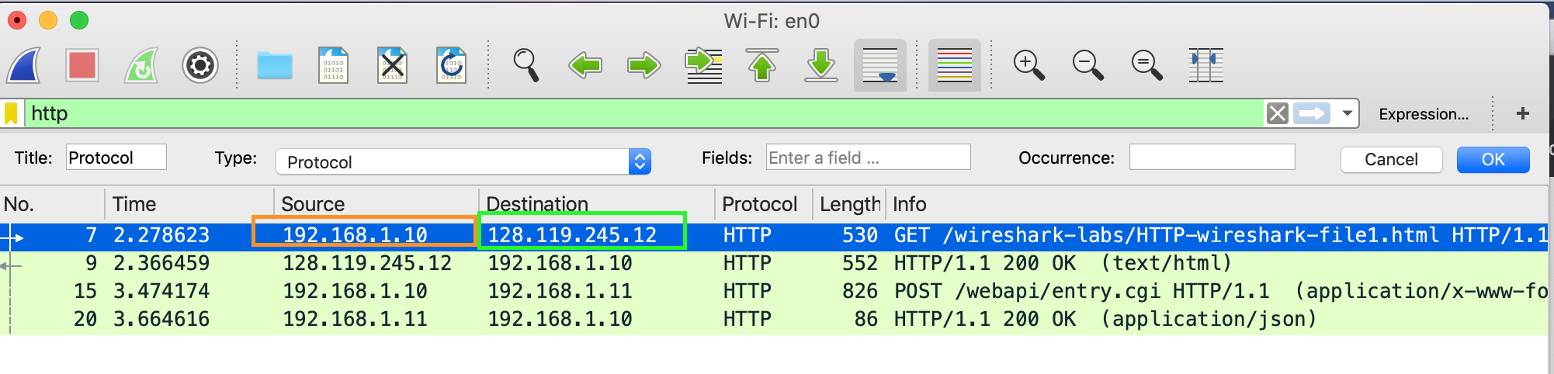
4. What is the status code returned from the server to your browser?  
   200 OK, this is visible on the first line of the return and under info in wireshark. Highlighted in orange below.  
   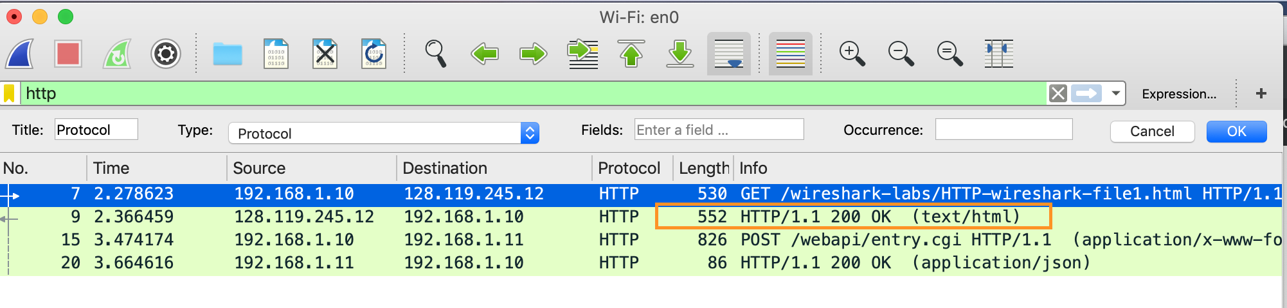
5. When was the HTML file that you are retrieving last modified at the server?  
   Sunday April 29th, 5:59:01 GMT, visible under the “Last-Modified” field of the return from server. Outlined in orange below  
     
   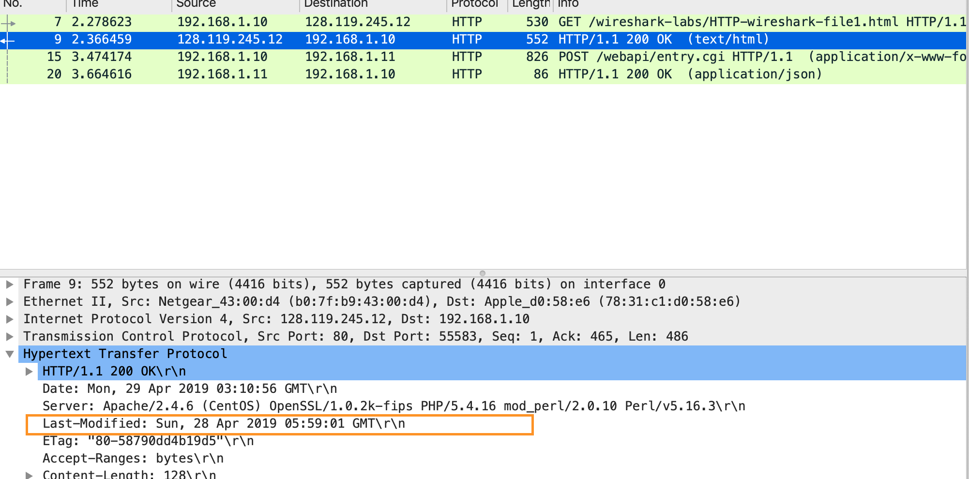
6. How many bytes of content are being returned to your browser?  
   128 bytes, visible under return HTTP from server under “File Data” field – outlined in orange below.   
   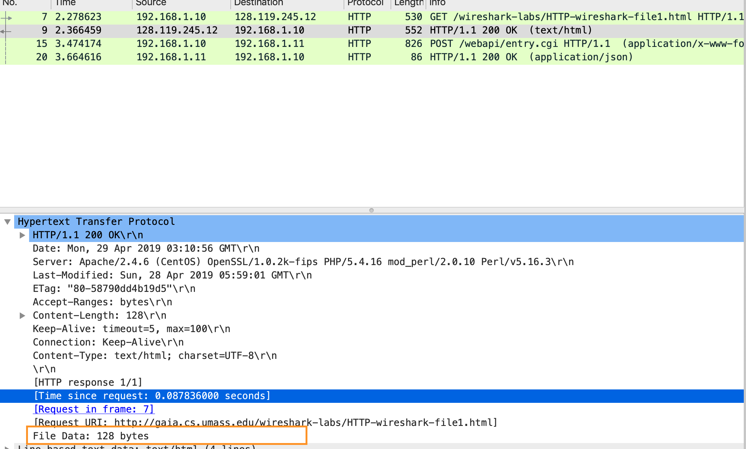
7. By inspecting the raw data in the packet content window, do you see any headers within the data that are not displayed in the packet-listing window? If so, name one.  
   The only thing I see is the actual HTML data payload, I do not know if this counts as part of the header file or is separate  
   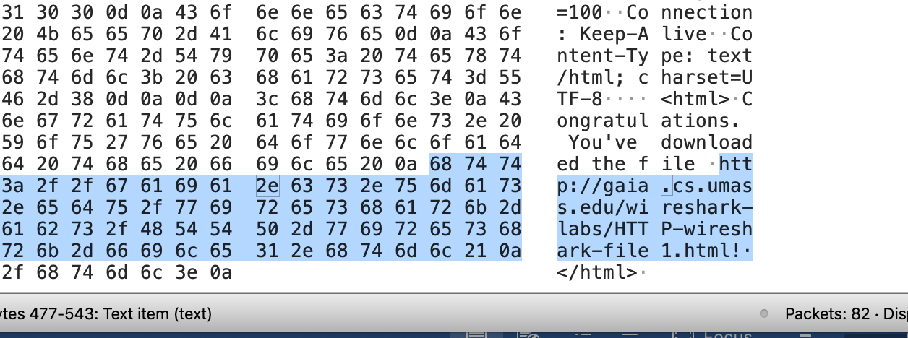  
     
     
   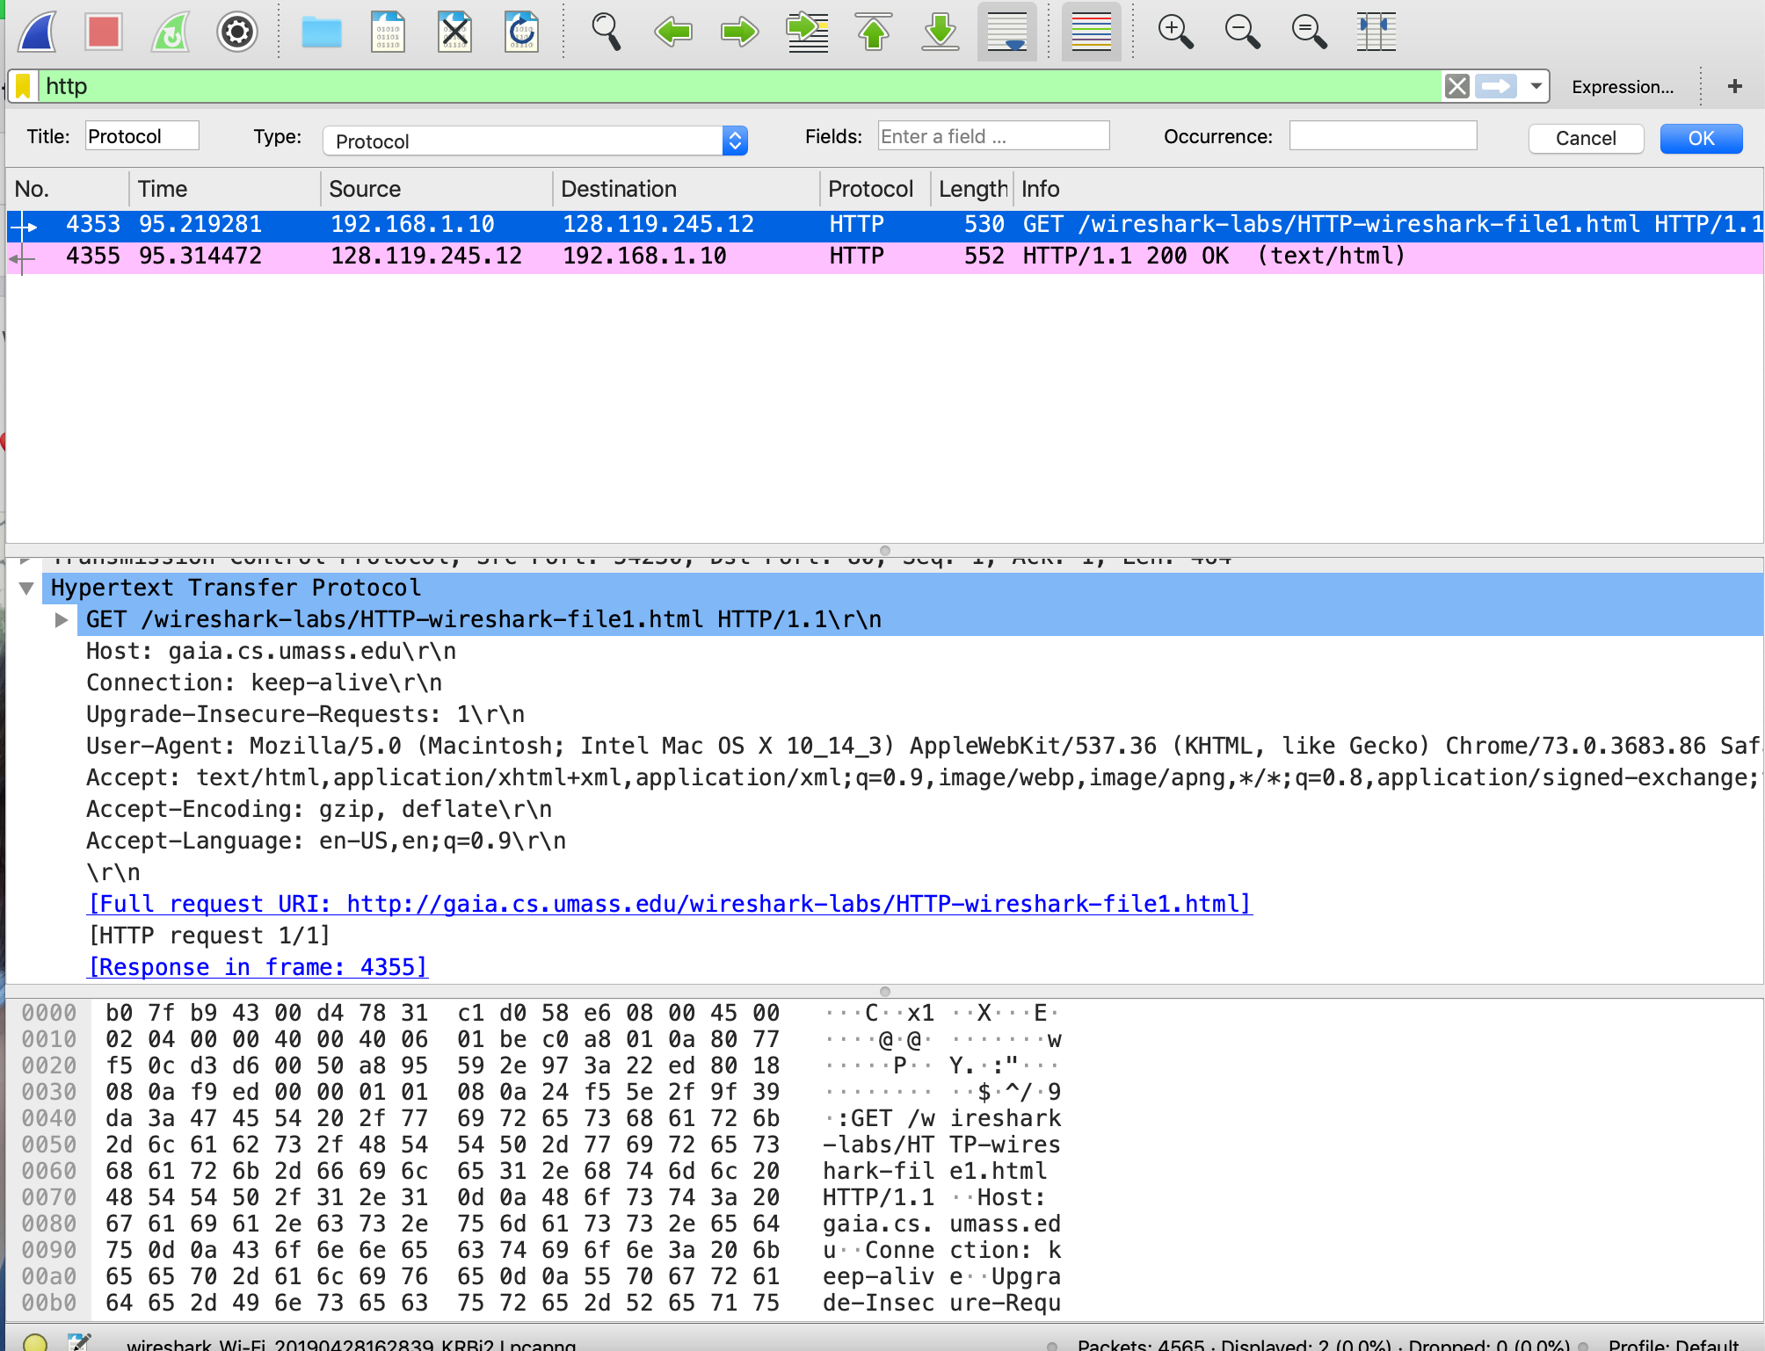

# The HTTP CONDITIONAL GET/response interaction

1. Inspect the contents of the first HTTP GET request from your browser to the server. Do you see an “IF-MODIFIED-SINCE” line in the HTTP GET?  
   No, I do not.
2. Inspect the contents of the server response. Did the server explicitly return the contents of the file? How can you tell?  
   Yes, you can see the actual HTML contents within the   
     
   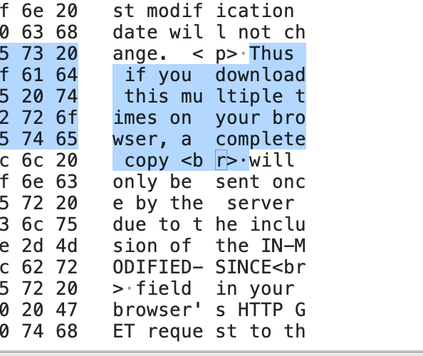
3. Now inspect the contents of the second and third HTTP GET requests from your browser to the server. Do you see an “IF-MODIFIED-SINCE:” line in one of the HTTP GETs? If so, what information follows the “IF-MODIFIED-SINCE:” header?  
   Yes, it says if modified since Tue, 23 Sep 2003 05:35:00 GMT (using the traces provided by instructor). See screen shot included below  
     
   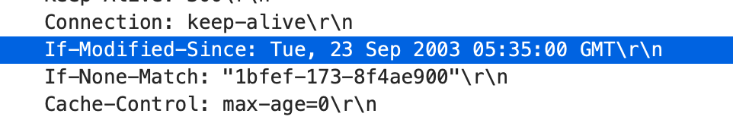
4. What is the HTTP status code and phrase returned from the server in response to the HTTP GET with IF MODIFIED SINCE (if there is one)? Did the server explicitly return the contents of the file? Explain.  
   It was status code 304 which is “not modified”, and no, the contents of the file were not returned as evidenced by the fact there is no new HTML payload. This is because the file has not been recently modified, and as such does not need to be retransmitted. Essentially the client is telling the server “Hey, I last saw the website on date X, are there any updates?” and the server is responding with “Oh, don’t stress, save your time and just show them that – it is the latest version!”  
     
   In this screenshot you can see the 304 status code  
     
     
   In this screen shot you can see there is no HTML response included  
   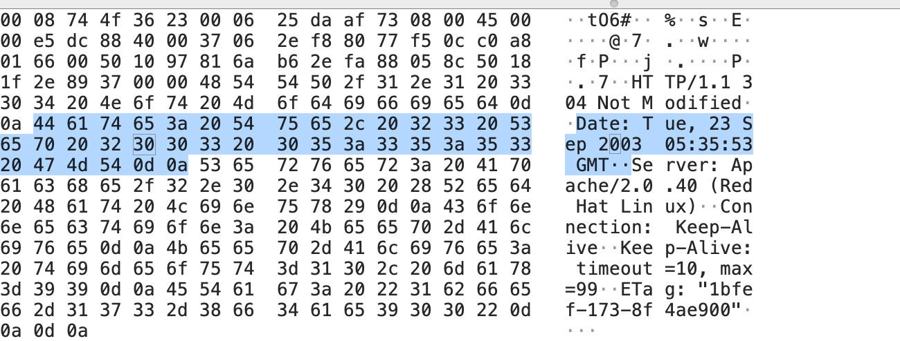

Retrieving Long Documents  
  
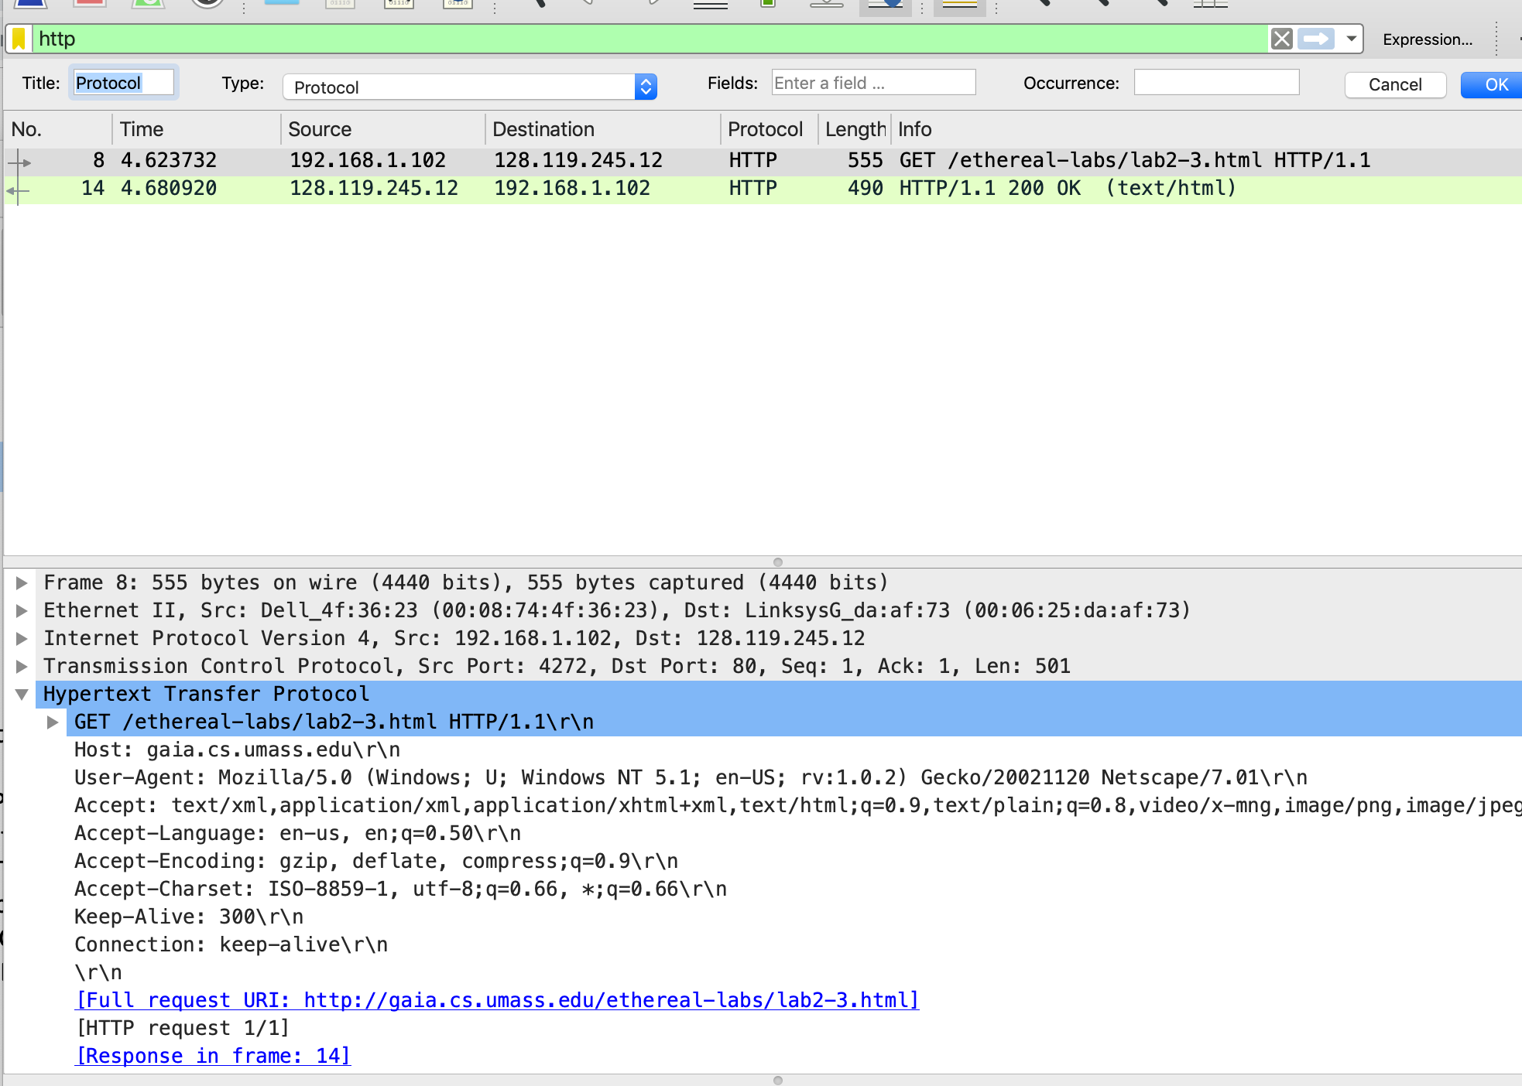

1. How many HTTP GET request messages did your browser send? Which packet number in the trace contains the GET message for the Bill or Rights?  
   My browser set a single HTTP get request message, as seen in the above screen shot.
2. Which packet number in the trace contains the status code and phrase associated with the response to the HTTP GET request?  
   Both are in the first packet number, which in wireshark is labeled as “Frame 10”. This was found by expanding the different reassembled TCP segments in wireshark.  
   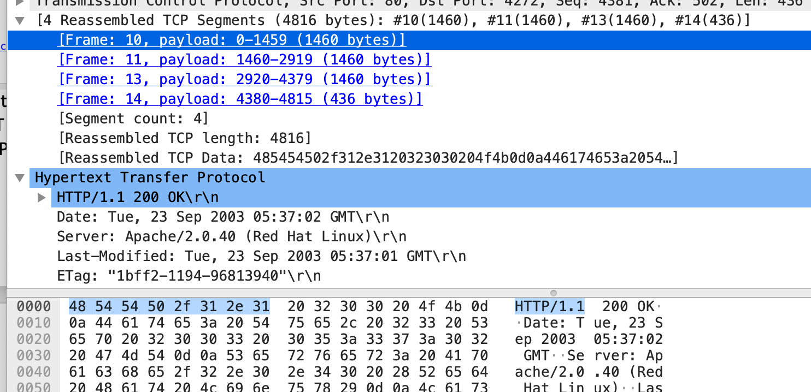
3. What is the status code and phrase in the response?  
   The status code was 200, with an OK response, as seen in the above screen shot.
4. How many data-containing TCP segments were needed to carry the single HTTP response and the text of the Bill of Rights?  
   The Bill of Rights is spread across all four TCP segments.   
   Evidence of the bill of rights in the first packet (highlighted section)  
   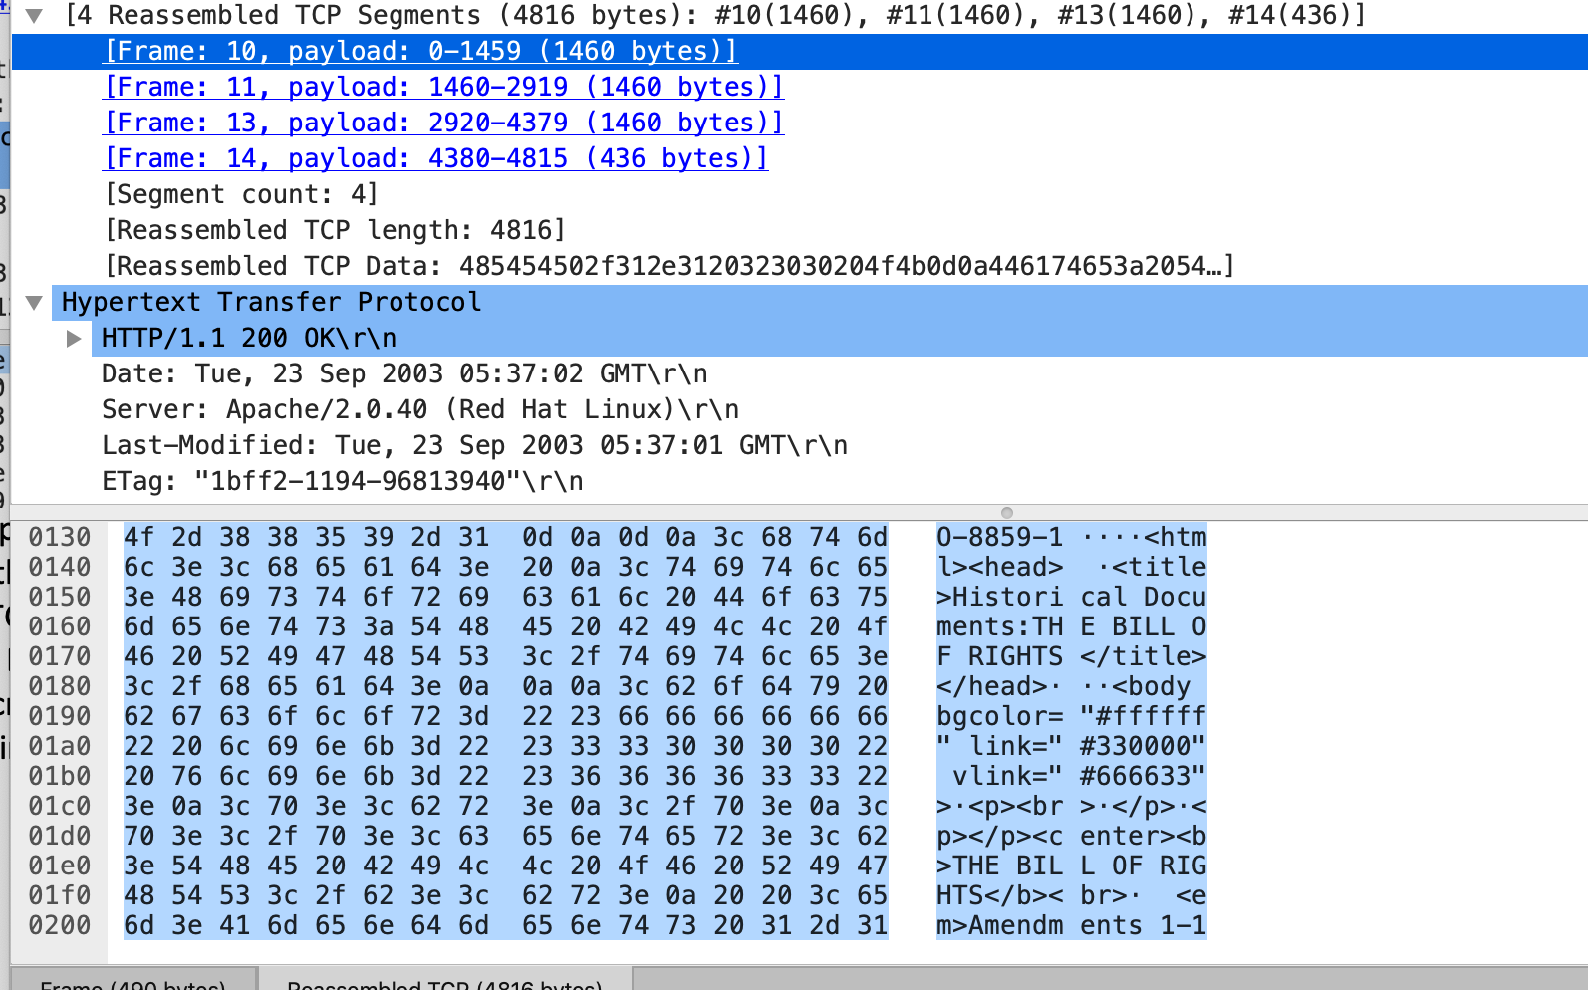  
   Second packet  
   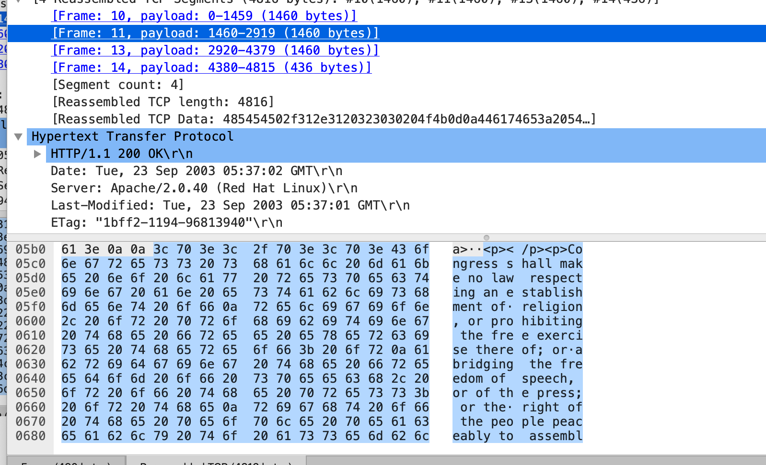  
   Third packet  
   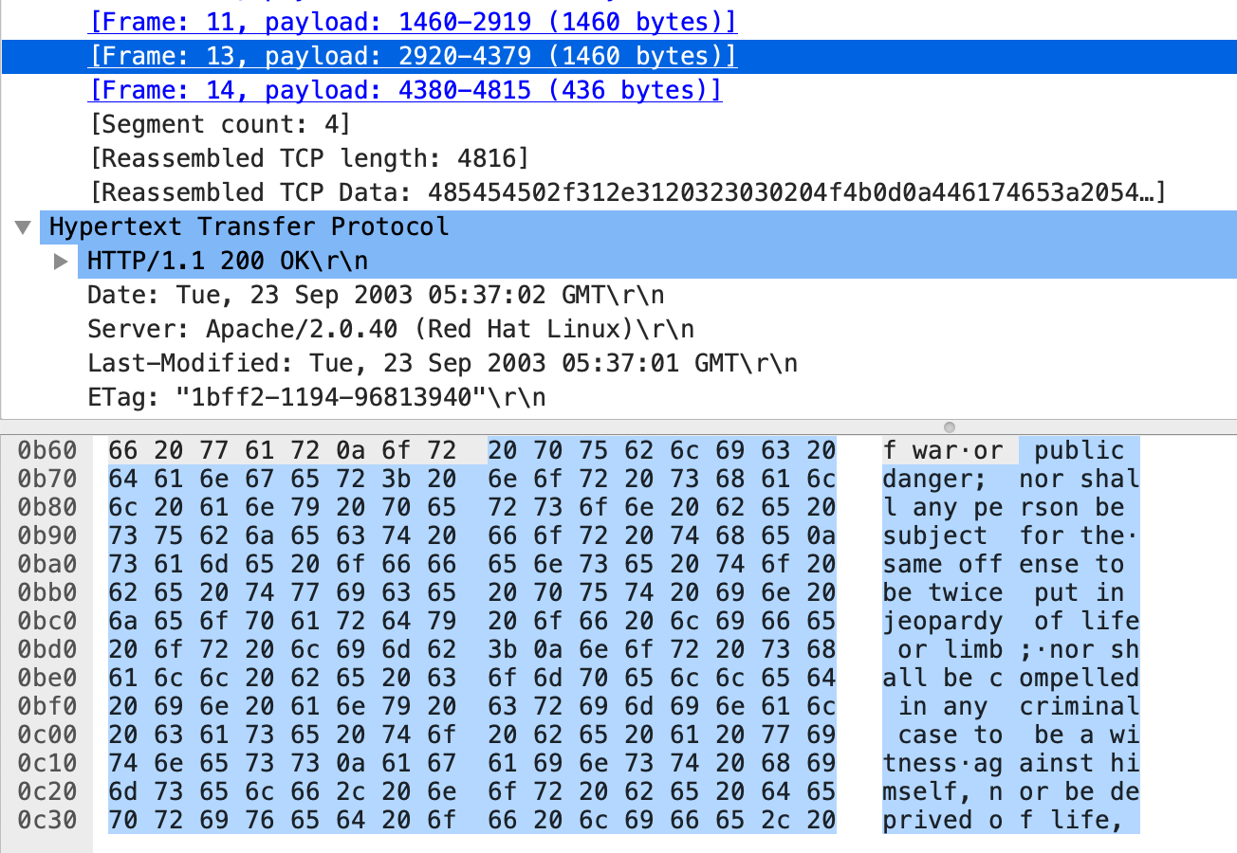Fourth Packet:  
   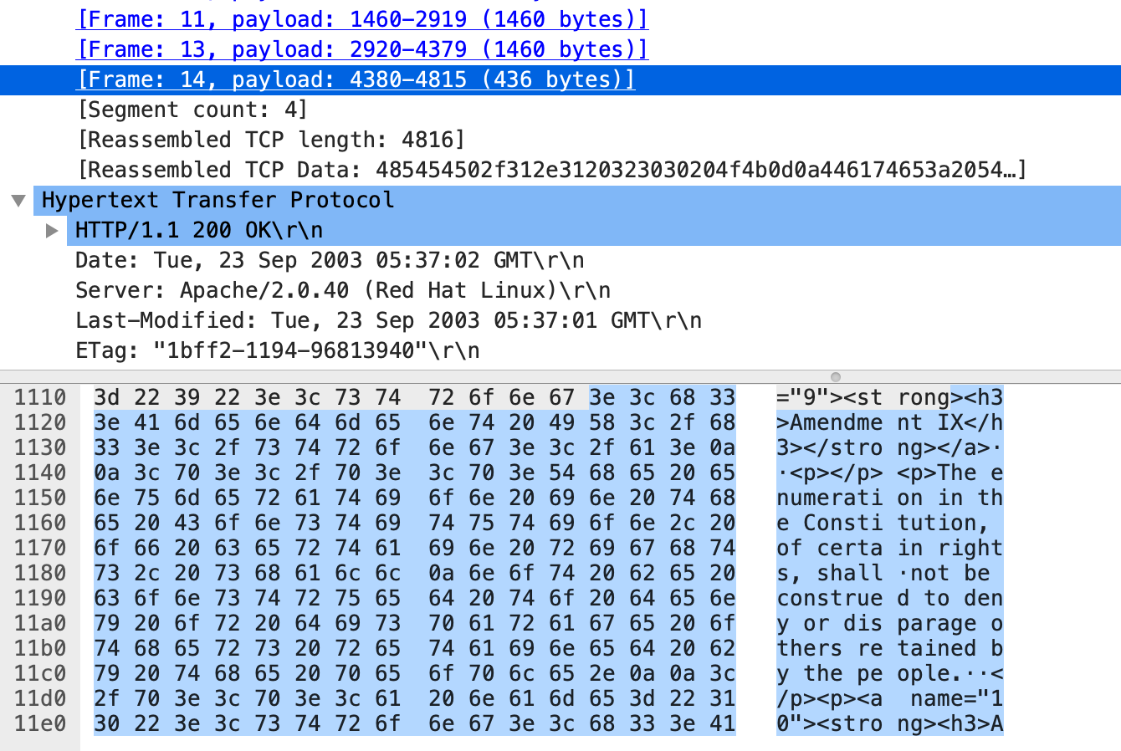

HTML Documents with Embedded Objects  


1. How many HTTP GET request messages did your browser send? To which Internet addresses were these GET requests sent?  
   There were three different GET requests sent, outlined by the black squares above. They went to three different destinations: first the website with IP of 128.119.245.12, second the “logo-footer” image with an IP of 165.193.123.218, and third the “cover.jpg” request to IP of 134.241.6.82.  
     
   These IP are visible in the black highlighted section was the destination.
2. Can you tell whether your browser downloaded the two images serially, or whether they were downloaded from the two web sites in parallel? Explain.  
   They were downloaded in parallel. If you look at the start time of the two images, outlined in the orange box, you see that they start at time 7.305 and 7.308, and if you compare these to the received time outlined in green with times 7.333 and 7.589 – the two requests were sent before the first image was finished downloading. Thus, the images were downloaded in parallel.

# Section 5 HTTP Authentication

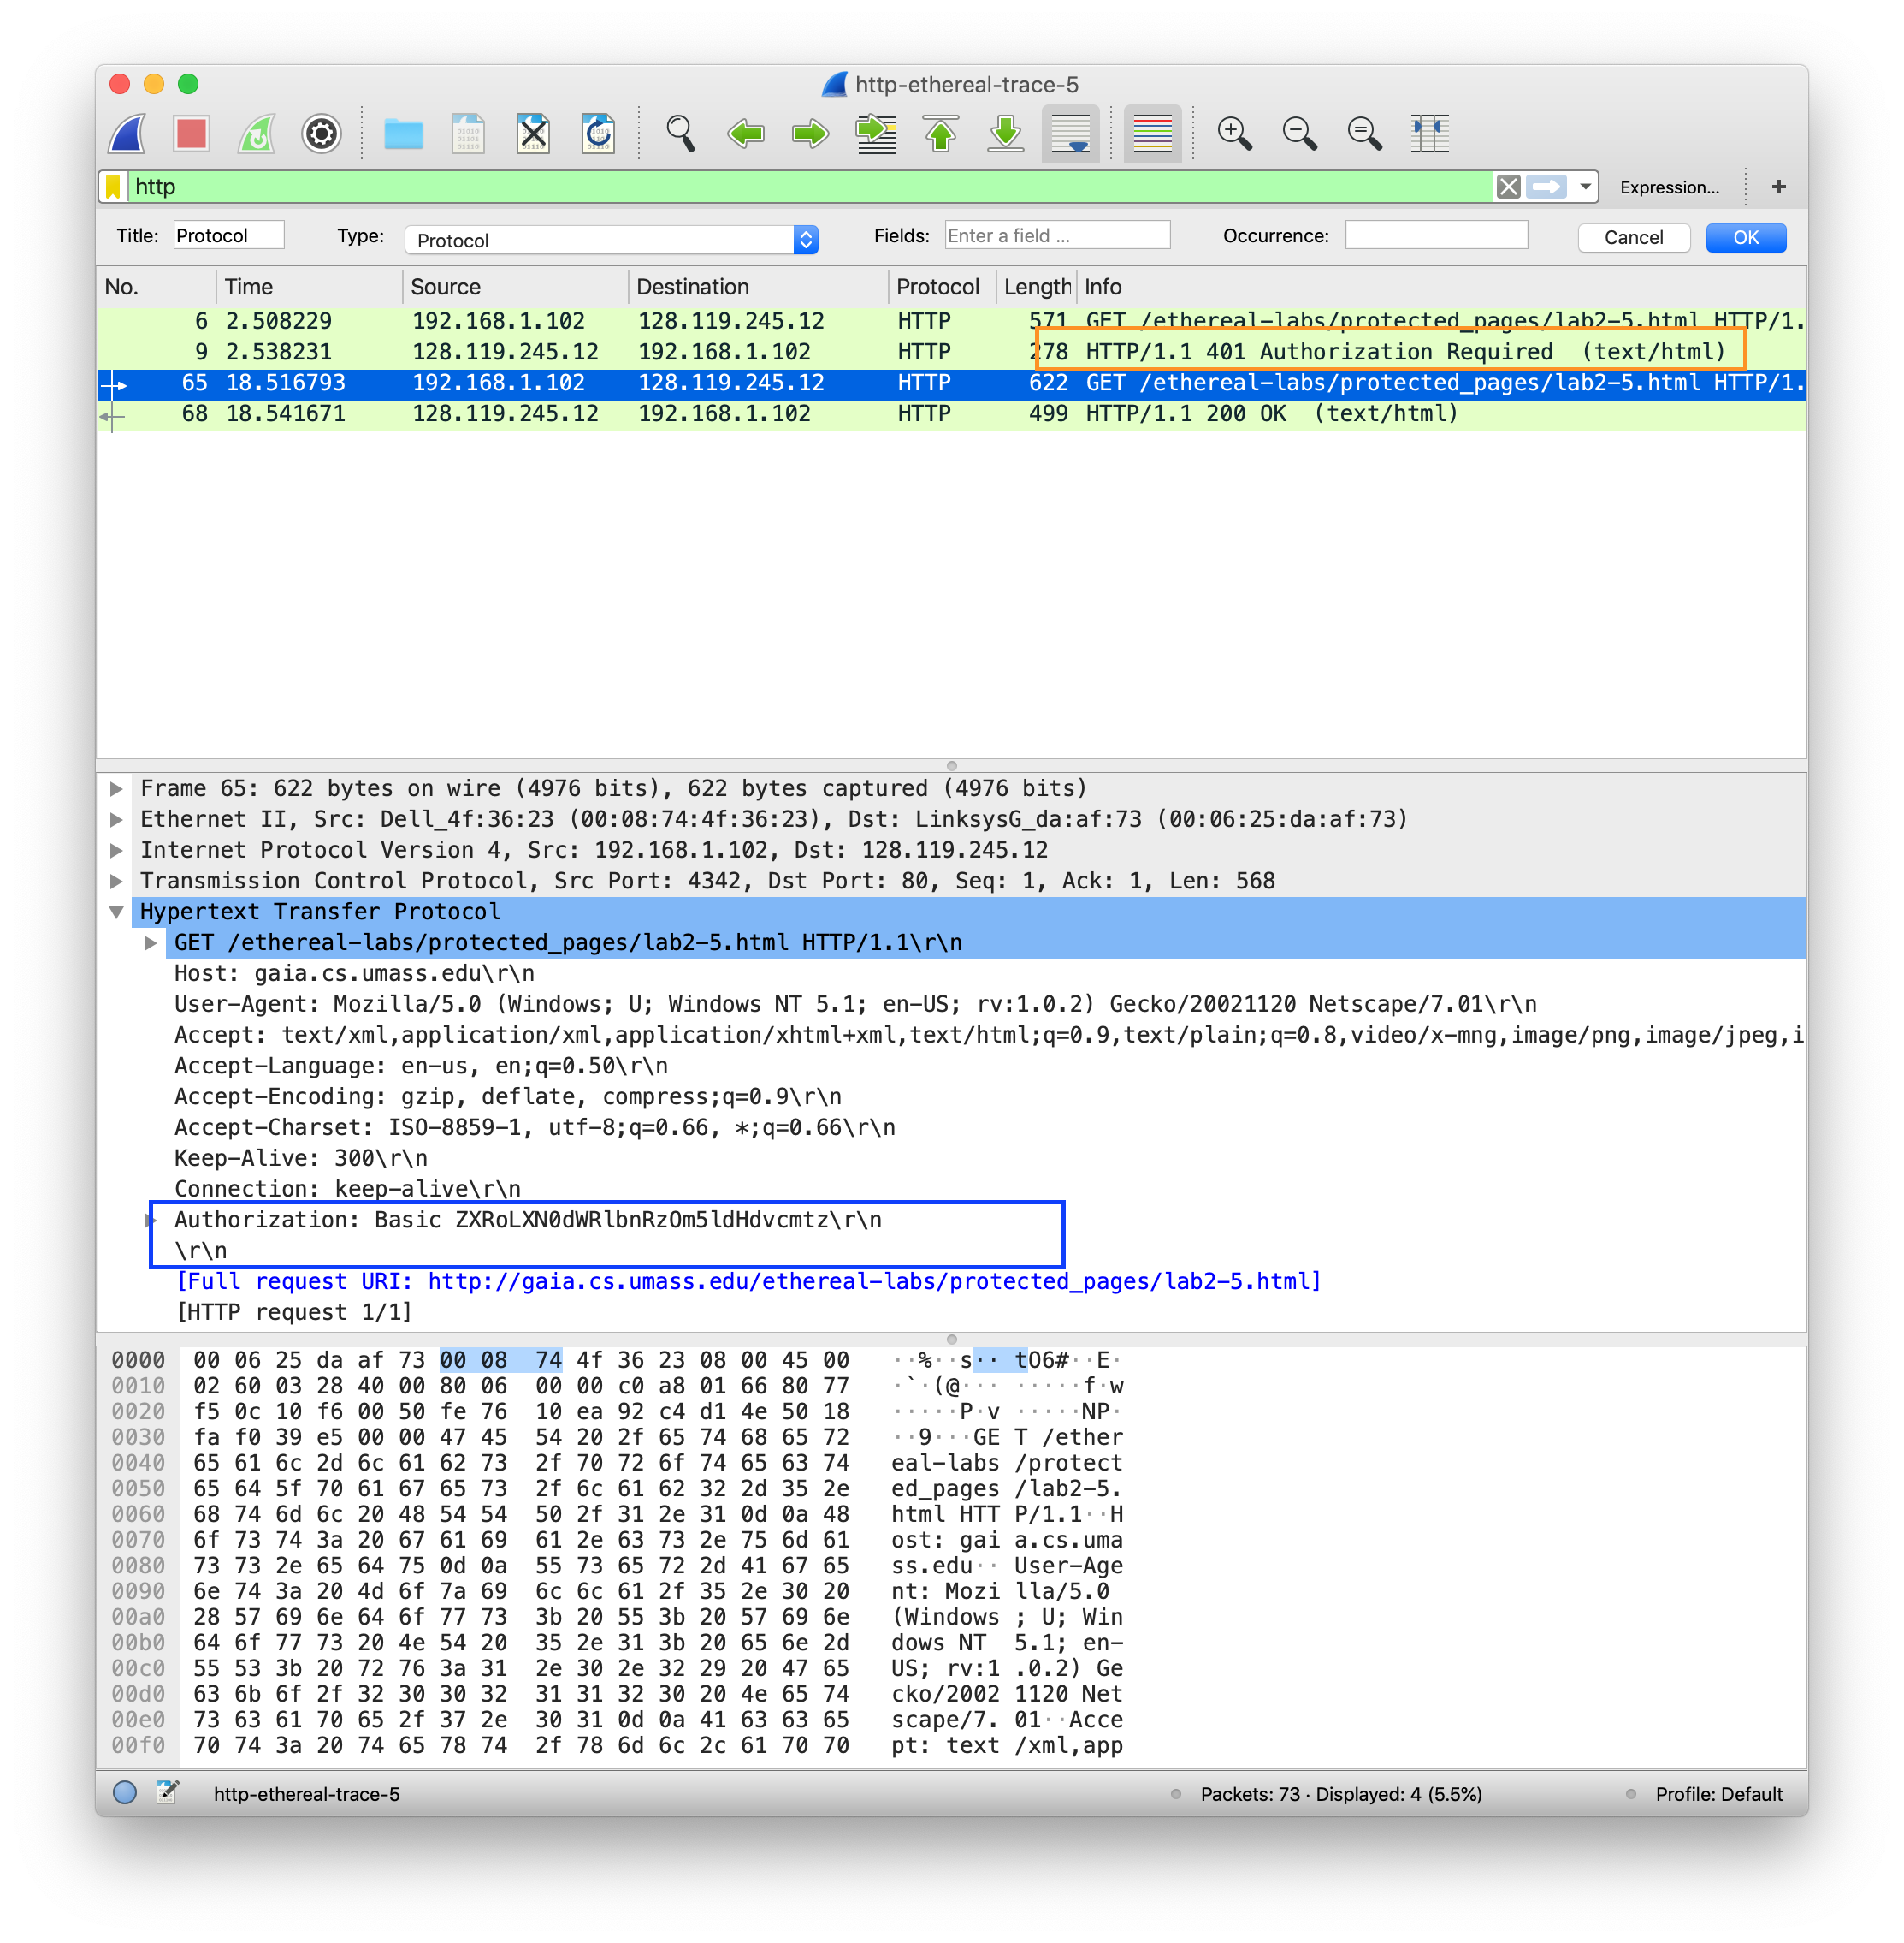

1. What is the server’s response (status code and phrase) in response to the initial HTTP GET message from your browser?  
   The initial response is 401, Authorization required. Outlined in the screen shot in orange.
2. When your browser’s sends the HTTP GET message for the second time, what new field is included in the HTTP GET message?  
   An authorization field is added to the GET message, outlined in blue. This was not present in the first GET request.